**HealthAI: Intelligent Healthcare Assistant Using IBM Granite**  
**Category:** Cloud Application Development  
**Skills Required:** Python, IBM Cloud, Scikit‑Learn

**Team ID:** NM2025TMID03660

**Team Size:** 4

**Team Leader:** PRATHISHA J

**Team Member:** PRIYANGA B

**Team Member:** PRIYANKA S

**Team Member**: RAHIN APSANA M

**Project Description**

HealthAI harnesses IBM Watson Machine Learning and Generative AI to provide intelligent healthcare assistance, offering users accurate medical insights. The platform includes:

* **Patient Chat:** Answer health‑related questions with clear, empathetic responses.
* **Disease Prediction:** Evaluate user‑reported symptoms to deliver potential condition predictions, likelihood assessments, and recommended next steps.
* **Treatment Plans:** Generate personalized, evidence‑based treatment plans (medications, lifestyle modifications, follow‑up testing).
* **Health Analytics:** Visualize and monitor patient health metrics (heart rate, blood pressure, blood glucose, etc.) with AI‑driven insights.

Built with Streamlit and powered by IBM Watson and the Granite‑13b‑instruct‑v2 model, HealthAI ensures a seamless, user‑friendly experience, secure API key management, and responsible data handling—empowering users to make informed health decisions with confidence.

**Scenarios**

1. **Symptom‑Driven Disease Prediction**
   * *Action:* User inputs symptoms (e.g., headache, fatigue, mild fever).
   * *Outcome:* HealthAI analyzes symptoms plus patient profile, returns potential conditions with likelihoods and next‑step recommendations.
2. **Personalized Treatment Planning**
   * *Action:* User enters a diagnosed condition.
   * *Outcome:* AI generates a comprehensive treatment plan including medications, lifestyle advice, and suggested tests.
3. **Health Trends Insight**
   * *Action:* User views the Health Analytics dashboard.
   * *Outcome:* Charts of vital signs over time appear alongside AI‑generated insights highlighting concerns and improvement tips.
4. **On‑Demand Patient Chat**
   * *Action:* User asks any health‑related question via chat interface.
   * *Outcome:* AI provides an empathetic, fact‑based answer, acknowledges limitations, and advises when to consult a professional.

**TECHNICAL ARCHITECTURE**

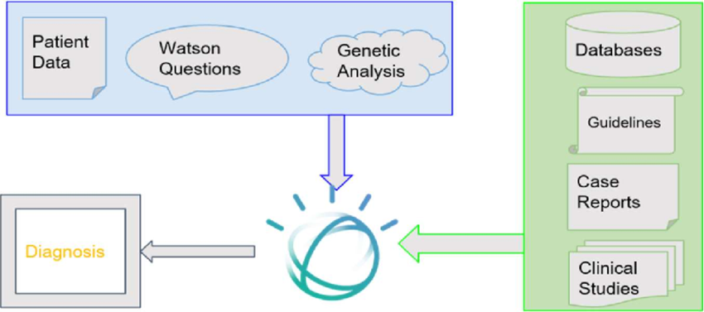

**Prerequisites**

1. **Python (3.7+)**
2. **Streamlit** for frontend UI
3. **IBM Watson SDK** and **Granite‑13b‑instruct‑v2** model via Hugging Face (transformers, accelerate, bitsandbytes)
4. **Scikit‑Learn** (for auxiliary analytics)
5. **IBM Cloud Account** with Watson Machine Learning service deployed
6. **Sufficient Hardware** (≥16 GB RAM; NVIDIA GPU with ≥8 GB VRAM recommended)
7. **Internet Connection** for initial model downloads
8. **Project Structure:**
   * app.py (Streamlit app entry point)
   * templates/ (if using Flask alternatively)
   * static/ (CSS, images)

**Project Setup & Architecture**

1. **Model & Libraries Selection**
   * Confirm Granite‑13b‑instruct‑v2, transformers, accelerate, bitsandbytes, PyTorch, Streamlit.
2. **System Design**
   * Input → AI inference → Data processing → Visualization → UI.
   * Secure handling of API keys and patient data.
3. **Development Environment**

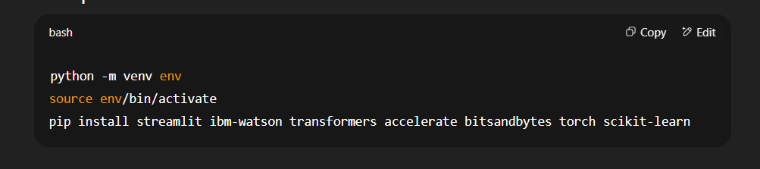

**Core Functionalities**

* **Activity 1:** Load Granite model and IBM Watson credentials.
* **Activity 2:** Implement Streamlit pages/components:
  + Chat input & response display
  + Symptom form → prediction
  + Condition form → treatment plan
  + Analytics charts
* **Activity 3:** Develop helper modules:
  + generate_response() (Granite inference)
  + predict_disease() (symptom analysis)
  + create_treatment_plan()
  + compute_health_metrics() (analytics)
* **Activity 4:** Secure API key/config management (e.g., using environment variables).

**Data Handling & Logic**

* Store session‑based chat history and analytics in memory (or lightweight DB).
* Process inputs through AI functions, format outputs for UI.
* Aggregate time-series health data for insights.

**Frontend Development (Streamlit)**

* **Layout:** Sidebar navigation (Chat, Prediction, Treatment, Analytics).
* **Forms & Inputs:**
  + Text inputs for chat & symptoms
  + File uploader (optional) for health logs
* **Visualization:**
  + Line charts for vitals (Streamlit’s st.line_chart)
  + Tables for predicted conditions & treatment steps

**Integration & Testing**

1. **Local Run:**

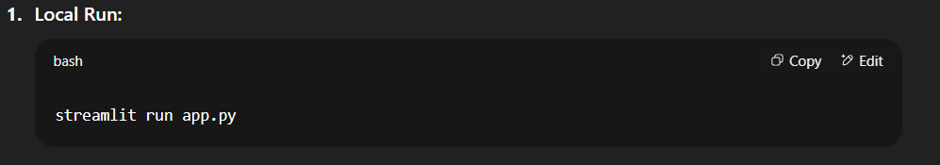

1. **Test Flows:**
   * Chat Q&A
   * Symptom → prediction
   * Condition → treatment
   * Data upload → analytics
2. **Debug & Refine UI/UX** based on feedback.

**Deployment**

1. **Containerize:** Dockerfile with streamlit image.
2. **Host:** IBM Cloud Run or similar.
3. **SSL & Security:** Ensure HTTPS, secure API key storage.
4. **Monitoring:** Track errors, usage metrics, model performance.

**Documentation & Handover**

* **README:** Setup, usage, API reference.
* **User Guide:** Screenshots, feature descriptions.
* **Demo Video:** https://drive.google.com/file/d/1BLbZqL1Wh79VcvT7xCTNid-EYhLvzKwz/view?usp=drive_link
* *HealthAI* delivers an end-to-end intelligent healthcare assistant—streamlining medical information access, personalized recommendations, and health analytics for better patient engagement and outcomes.